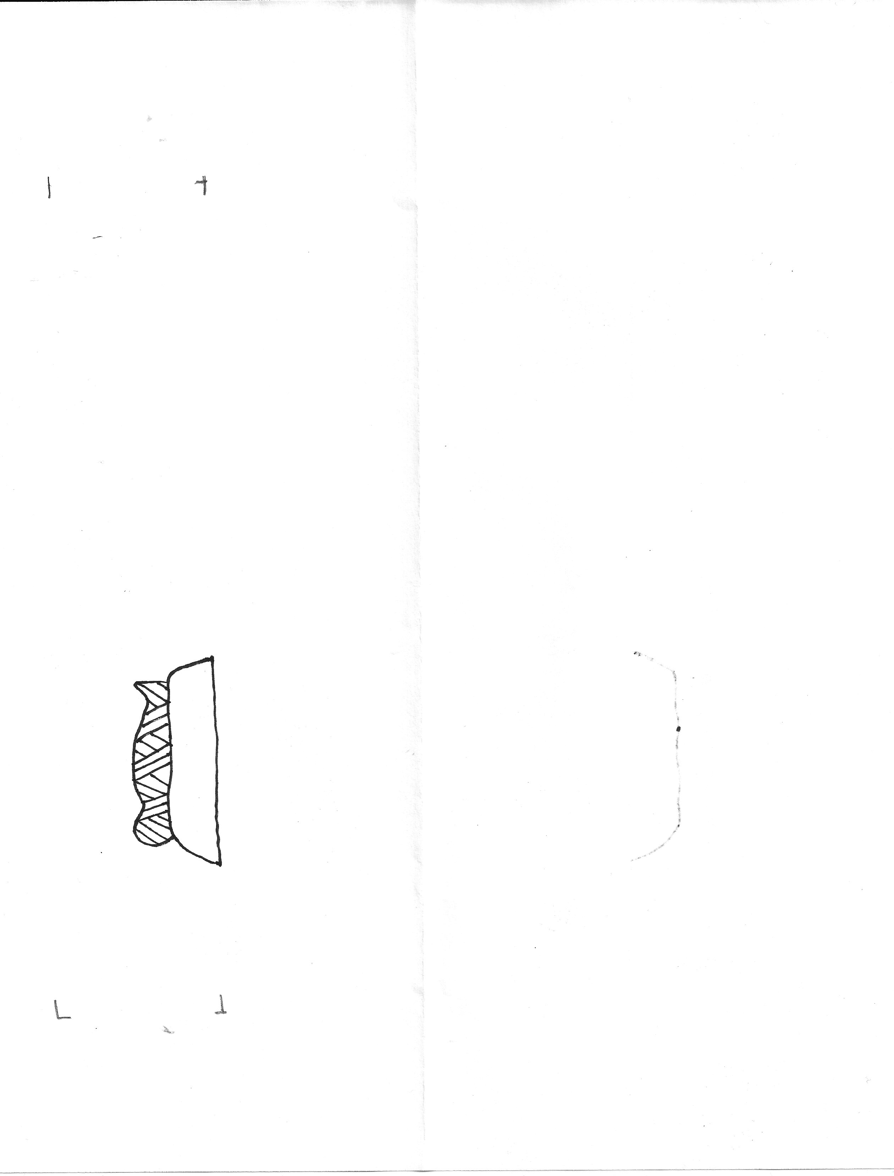
CHRIST has
Risen!
He died
CHRIST has
Risen!
CHRIST has
Risen!
CHRIST has
Risen!
He died
He died
He died
CHRIST has
Risen!
CHRIST has
Risen!
He died

